Slide 1



Slide 2

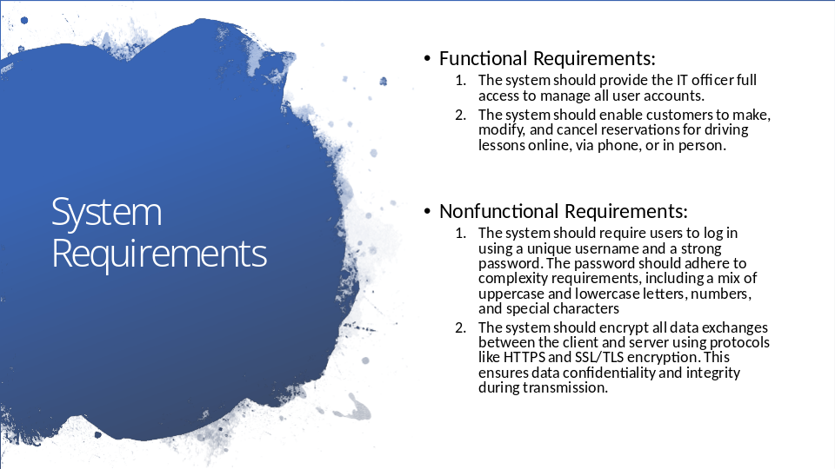

Functional requirements are essential jobs that the system must be able to do for DriverPass.

The first functional requirement tells us that the system needs to allow anyone with an “IT officer” job title/role in the DriverPass company to be able to access and make changes to any other person’s account. This helps the IT officer of DriverPass to be able to do their job.
The second functional requirement informs us that the system should have some way for a customer of DriverPass to make, change, or cancel a reservation for a driving lesson. The customer should also have the option to do these actions online (Over the Internet), by phone call, or in person with a company secretary. This is how the system will deal with reservations for the DriverPass Company.

Nonfunctional requirements are rules about how the system should work, not what a system can do. This could be rules about how fast the system can perform a job. It could also be rules about the safety of the system from people trying to gain access without permission. These requirements are an indicator of how well a system works and meets the expectations of the DrivePass company.

The first nonfunctional requirement explains that the system needs to identify each person by a username (Name chosen by the person using the system to be tied to their account) and a password (Secret phrase. that is the key to the account). The password should be tough to guess, and the requirement talks about the rules to determine how difficult to guess the password is. This helps to keep the system safe from people trying to access the system illegally.
The second, nonfunctional requirement outlines that the system should scramble all sensitive information whether while that information is being passed around or whether that information is being stored. This is to help prevent people trying to steal information from DriverPass.

Slide 3

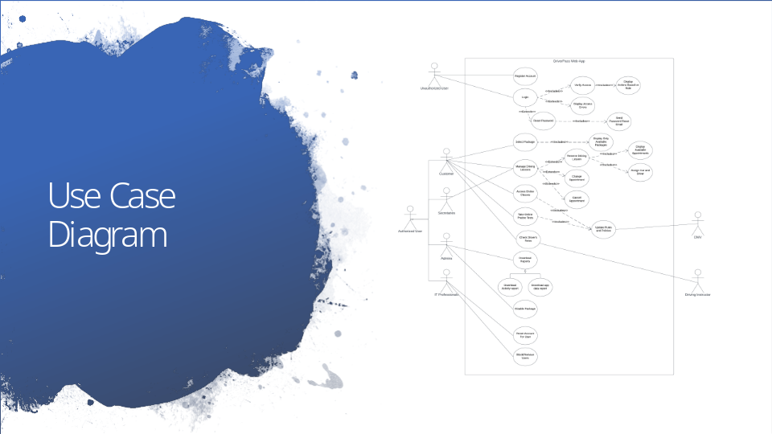

This diagram shows the roles of people who will interact with the system and what actions they can take. The roles include customers, secretaries, admins (the owner and other business leadership of DriverPass), and IT professionals (Technical persons who maintain the system). There is also a distinction between people who have logged in to the system and those who haven’t. The diagram also includes people who contribute information to the system, such as the driver and the DMV. Some of the actions that can be taken are creating a new account, logging into an existing account, choosing a learning package, making reservations for driving lessons, making changes to a reservation, canceling a reservation, using the online practice tests, using the online classes, viewing the driver’s notes, getting the activity report, getting general reports, revoking access to certain people, or resetting a password for yourself or others (If you have the permission to do so). This design helps to meet the needs of DriverPass by outlining how only certain roles can take certain actions. This improves the system’s safety and security while also making it work according to the way DriverPass has outlined. This design also provides a way for the classes and online tests to be kept up to date by getting the latest policies and rules from the DMV.

Slide 4

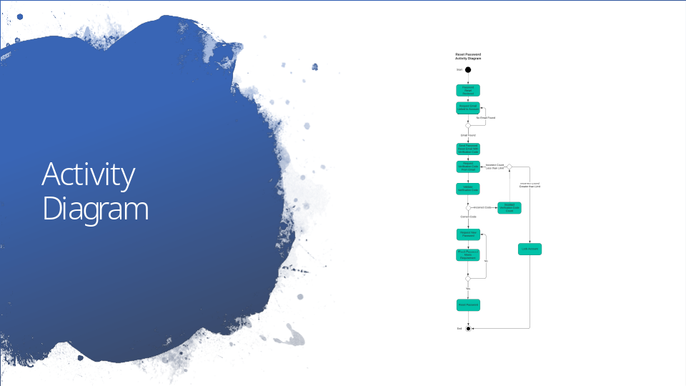

The activity diagram above describes the process for resetting a password.

The steps for this action are as follows:
- A user requests to reset their password.
- The system checks if there's an email associated with the user's account.
- If no email is found, the process loops back to request the email again.
- If an email is found, the process moves forward.
- The system sends a password reset email to the user's email address. This email contains a verification code.
- The user is expected to enter the verification code received via email.
- The system makes sure the verification the user entered matches the one in the system
- If the user enters an incorrect code but hasn’t reached the limit of attempts, the process allows them to try again.
- If the incorrect code is entered and the count of attempts exceeds the limit, the account is locked.
- If the code is correct, the process moves on to the next step.
- The user is prompted to enter a new password.
- The system checks if the new password meets the requirements that make it harder to guess.
- If the password does not meet the requirements, the user is prompted to enter a new password again.
- If the password meets the requirements, the password is reset.
- Upon successful validation, the password is reset.
- The process ends after the password has been successfully reset.

Allowing a user of the DriverPass system a way to reset their own password is one of the needs of the company. This diagram also accounts for security benefits, such as locking the account with too many failed attempts.

Slide 5

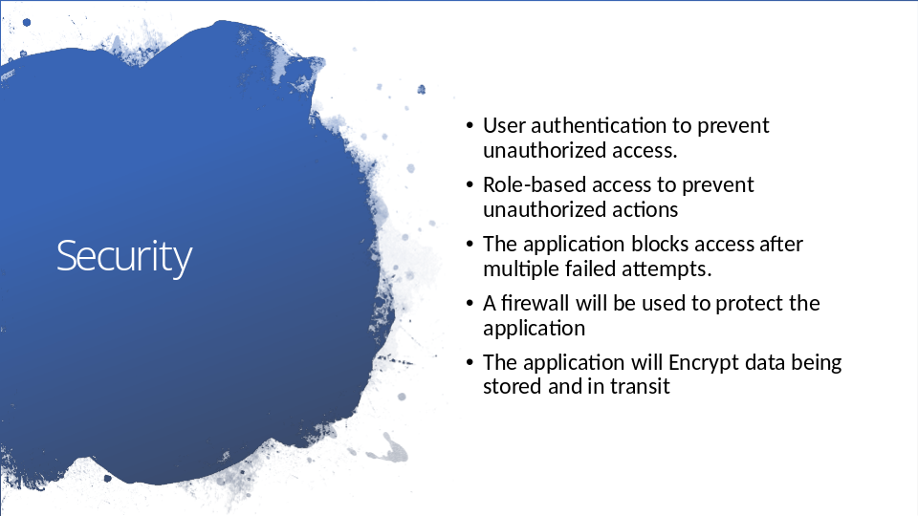

In the proposed design, the following tools are used to keep the system and the information it keeps safe from malicious people who want to bring the system down or access its information illegally.

- User Authentication: Only let people with the right credentials (username and password) use the system.
- Role-Based Access: People can only do things they're supposed to, based on their job or role.
Blocking After Failed Attempts: If someone gets the password wrong too many times, they can't try again for a while.
- Firewall Protection: Using a security system to act as a gatekeeper, deciding what requests to the system are safe and not including anything that could bring the system down or compromise the information that the system has.
- Data Encryption: Scrambling data so only authorized people can read it, both when it's stored and when it's sent over the internet.

Slide 6

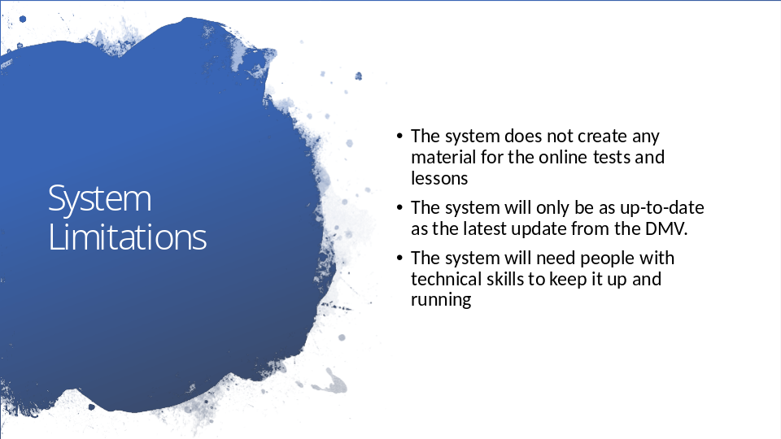

The system is limited because it cannot create test questions or lessons taught in the online classes. This needs to be provided before it can be presented to DriverPass students.
The system also cannot keep its information up to date by itself. It needs to rely on information about policies and rules from the DMV.
The system also cannot keep itself working. It will need technical people to upkeep it from time to time.

